John Imgrund

Project One: The Effects of Building Age on Property

**Project Goals:**

The age of a home used to always be an indicator of value. Property was something people could expect to make a profit on; flipping the homes they raised their families in into extra retirement money. However, in a post 2008 housing market crash world it is becoming much harder to sell your house for a profit. Is this the outcome of a stagnating economy, a market bubble readjusting, or are these aging homes starting to fall apart? While data can’t answer all the questions it is worth taking a look at the data we do have to answer some questions, mainly what effect does building age have on homes.

For the purposes of this report there are five questions being considered:

* What is the most common heating fuel by house age?
  + As climate consciousness becomes a more pervading mindset amongst Americans the fuel type their houses run on will become increasingly important
* How does age affect current building value?
  + Is age something that improves house value overtime or destroy it
* Does age effect number of rooms/ bedrooms?
  + As space in cities like Burlington becomes a premium, do houses get smaller?
* Does age effect property grade
  + Is the properties quality affected by age, or is it reliant on other factors?
* Does age effect total gross area
  + Does building earlier result in higher yields of gross area on a property?

**Class Diagram**

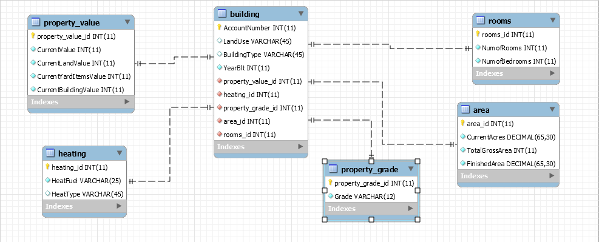

**Results**

**Note:** In order to maintain data that is concise and readable, age has been categorized by century.

**Question One:** What is the most common heating fuel by house age?

**Data:**

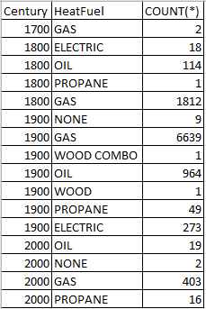

**Results:**

The most common heating fuel for each century is gas by a long shot. It should be noted that in the 1700’s oil and electricity hadn’t yet been leveraged as catalysts for creating power. It is also interesting to note that no home built in the 21st century is heated via electricity, which sounds counterintuitive to the growing climate consciousness of our time.

**Question 2:** How does age affect current building value?

**Data:**

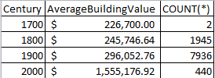

**Results:**

The data is clear, the newer the building the more it is worth. This increase is rather normal for the first two centuries of change, growing 8.4% and 20.4% respectively. However, from 2000 to 1900 the change is 425.3%. While the century is still relatively new, such a drastic increase suggests that large scale development is being done in Burlington compared to the majority of 20th century development. It should also be noted that these values are all values taken at the time of the survey and not reflective of their initial value.

**Question 3:** Does age effect number of rooms/ bedrooms?

**Data:**

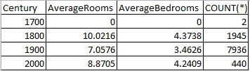

**Results:**

According to the data, the houses with the most rooms and bedrooms were made in the 19th century. In contrast the houses with the least rooms and bedrooms were created during the 20th century. While it looks like rooms are on the upswing again, it is still too early to tell if this will remain true throughout the decade. It is also interesting to note that several of Champlain Colleges large scale dorms were built in the last 1800’s, which could be a possible reason for the increased average numbers as some of those dorms had a hundreds of rooms.

**Question 4:** Does age effect property grade?

**Data:**

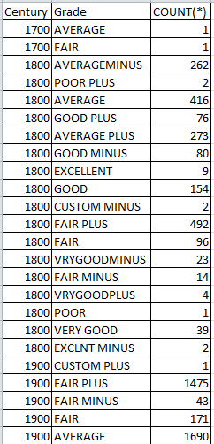 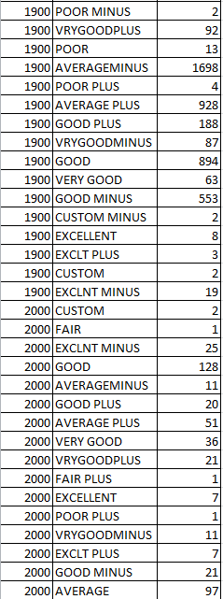

**Result:**

Combing over the data, the most likely grade for a home built in the 19th century is *Fair Plus*, a home built in the 20th century is *Average Minus*, and the 21st century is *Good*. It should be noted that the limited number of homes built in the 18th century do not show an outstanding grade above any other. This data indicates that homes built in the 19th century are usually rated in better condition than those built in the 20th century, but that 21st century design currently remains superior. However, the test of time will be the ultimate factor for the new 21st century buildings as most of them are still technically new when compared to the other centuries.

**Question 5:** Does age effect total gross area? **Data:**

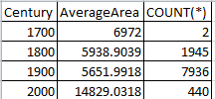

**Result:**

Average area from the 18th to the 19th century decreased by 17.4%, and from the 19th century to the 20th century it decreased by 5.1%. However, from the 20th to the 21st century there was an increase in average area of 162.4%, a shocking uptick compared to previous centuries. It is also reminiscent of the data collect on building value in question 2, adding to the conjecture that these newer properties being developed in the 21st century are large scale.

**MySQL Techniques**

After cleaning up the data in Excel, I brought the data in using the Excel to MySQL plugin. I created tables based on the questions that I was trying to answer. I added any possible data that could be relevant to the tables and also created a new column in each to be their primary keys. I then created a central table called “Building” that would house the account number (used at the primary key), the land use reason, the type of building it was, and the year it was built. I then added in foreign keys to connect all the tables by using the ALTER TABLE function.

From there it was simply about joining the proper tables together via the JOIN function and looking at the results. However, given the enormous amount of data, it was hard to properly look at the results so I created a formula to convert the year built into century built. To do this I used to DIV function to perform the math, then cast it as “century” for clarity in the data tables. I also utilized the AVG function to determine the average number for several of the columns. AVG is smart enough to calculate the averages based on group, so when using the GROUP function to group by century, it automatically averages out each century individually.